***[Capstone Category]***

|  |  |
| --- | --- |
| **Project Name** | **IOT Sensor Blinding: A ML Approach to Network Traffic Classification** |
| Team Lead: | Jeremy Gluck |
| Team Member(s): | Todd St. Onge, Xuchao ‘Steven’ Jiang, Alex Winstead, Matthew Craven |
| Faculty Advisor(s): | Dr. Terrance O’Connor, Dept of Computer Engineering and Sciences, Florida Institute of Technology |

Project Description: IoT devices exhibit patterns in their wireless transmissions that facilitate the creation of models to study their behaviour. In this study, we have constructed a labeled dataset of over 7000 samples of IoT device wireless communications from a variety of vendors. The dataset is hosted publicly online for use in further research. To showcase a usage of the dataset, we have constructed a machine learning based model to classify what signals are coming from which devices with 70% accuracy, verified using 30% of the dataset as the holdout set.

In a lab setting we procedurally triggered IoT devices while recording their traffic, allowing us to generate labels during the creation of the datapoints. The pcap files output from airodump were then parsed, using our own script, into csv format. The model we trained to differentiate which device is currently communicating on the network works currently with 70% accuracy using a 30% holdout set. We also tried to train a model to determine if a door lock was locking or unlocking and it achieved 50% accuracy, again with a 30% holdout set for verification. Both models tested used SciKitLearn’s RandomForestClassifier. The dataset currently contained 7392 labeled samples, and we have created a guide for future researchers to continue to populate the dataset.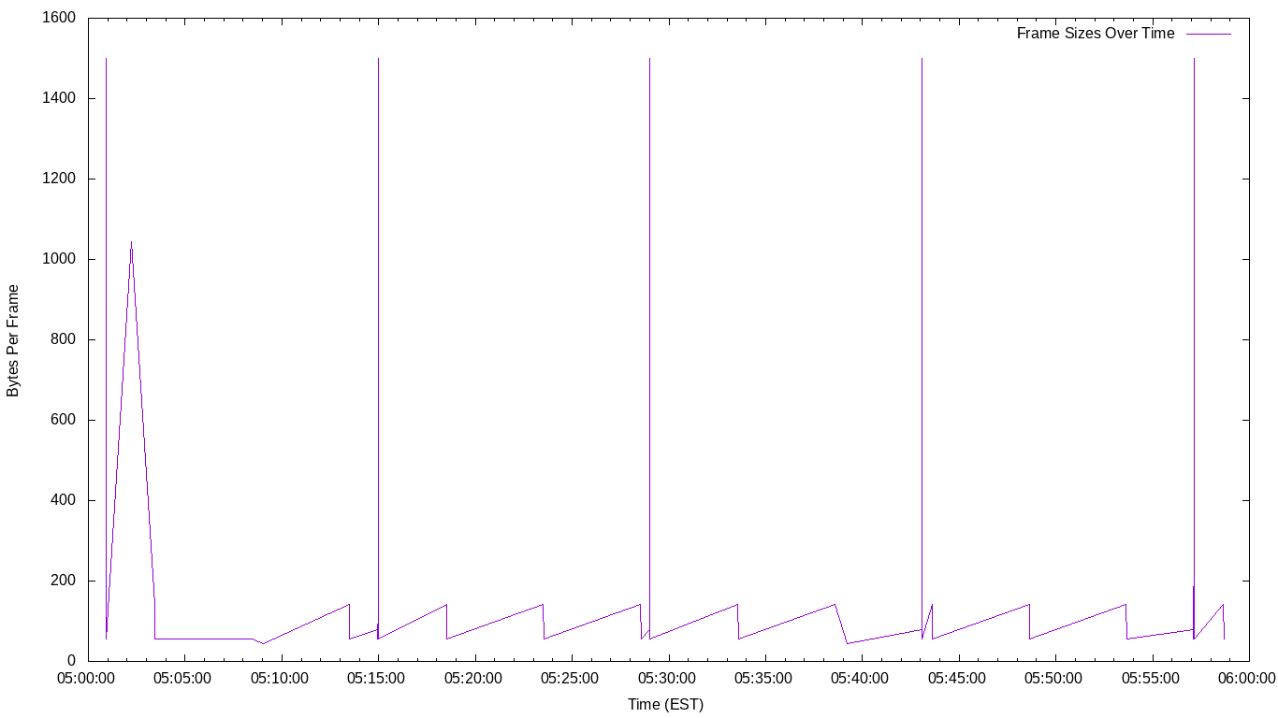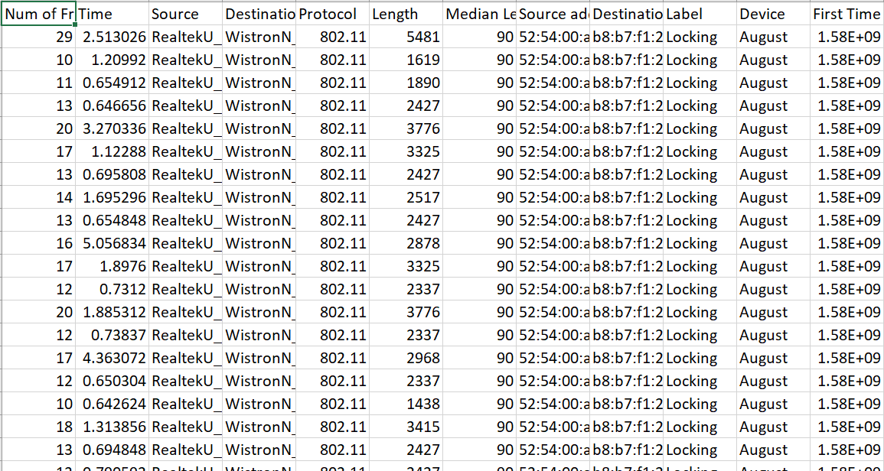

Further research can be done to improve the model for classifying IoT device behaviour from an unprivileged perspective. In addition, further data should be added from both devices already in the database and new devices.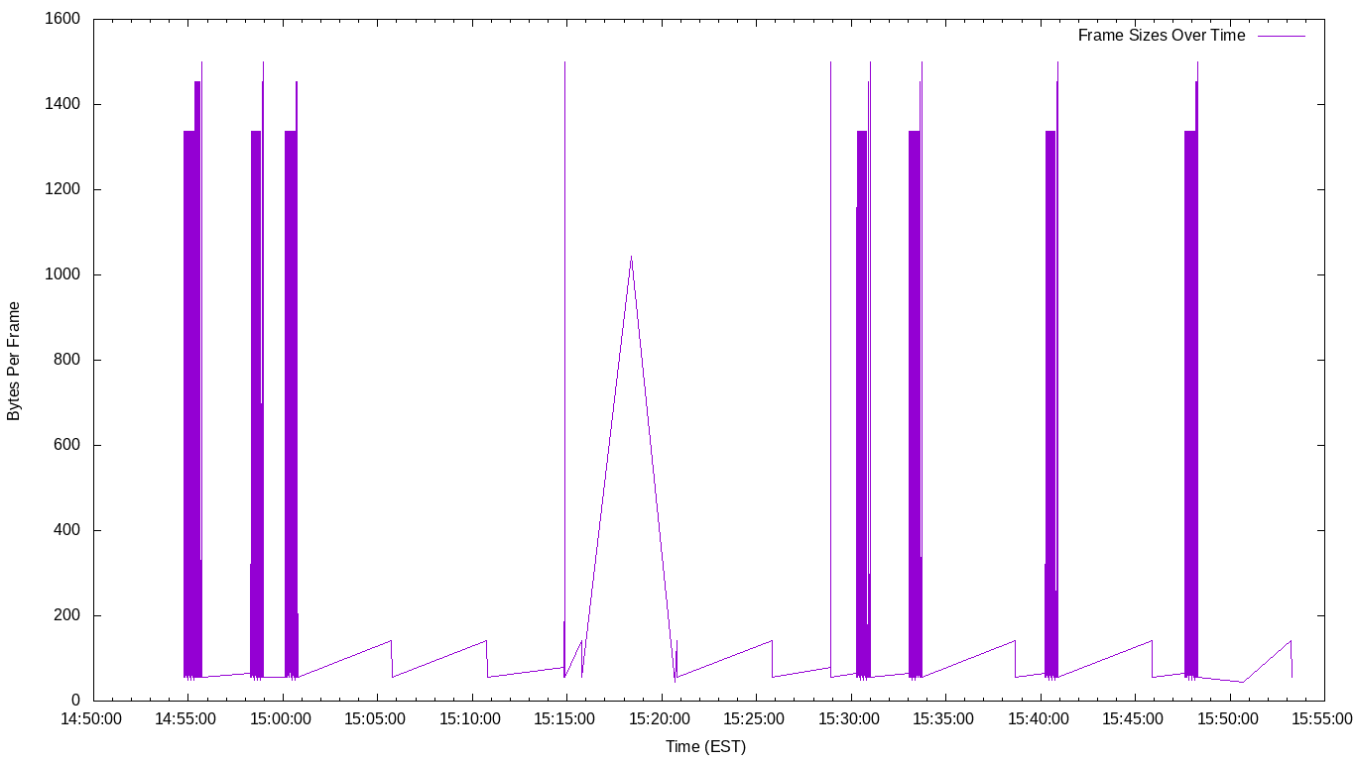

*Top Image: IoT Device traffic parsed into csv format*

*Middle Image: Ring Doorbell Heartbeat activity*

*Bottom Image: Example Model*